
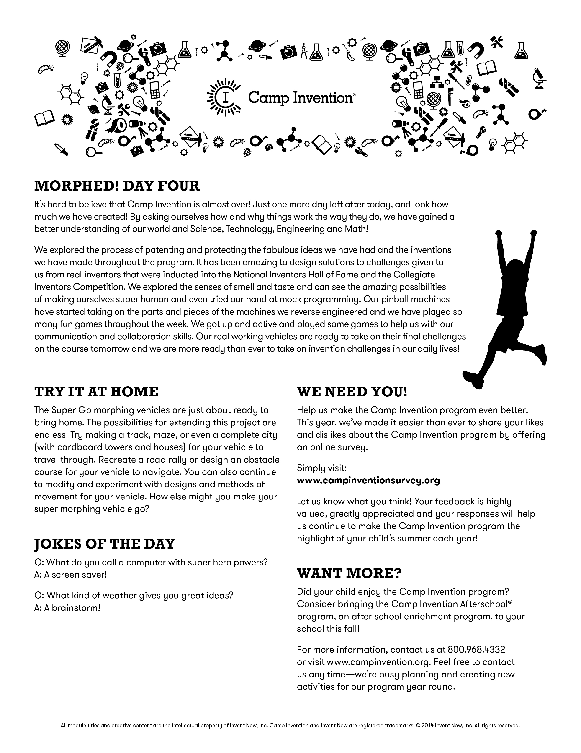
Tomorrow WEAR YOUR CAMP INVENTION T-SHIRT!
More info on back…

Parents
Your child’s safety is of the utmost importance to us. As a staff, we appreciate your commitment to signing your campers in and out each day, as well as your patience during pick up.

Last Reminder
Our highly-anticipated Inventors Showcase program will take place this Friday at 2:45pm in the Gym. All family and friends are welcome and encouraged to come. The children are very anxious to show you what they’ve been having fun creating and learning this week. Please join us in celebrating your children’s accomplishments!

Friday Showcase Dismissal
If you are attending our Inventors Showcase on Friday, we ask that you enter the school through the main office (the same location where you drop your kids off each day).
At that point you can “sign out” each of your campers in advance, so that when the Showcase has concluded, they can leave right with you!

Emergency Phone Number
In the event that you need to contact us for any reason this week, please call (724) 327-5456 extension 7002. Mrs. Lapaglia, our secretary will page me to the office, or take and relay a message. Thank you for your cooperation in advance.


SHARE WITH US
Post on the wall at Camp Invention Headquarters’ Facebook page and tell us what your child’s favorite activity for today was!

SPECIAL THANKS
The Camp Invention program is made possible through the assistance of a number of organizations, businesses and individuals that truly believe in the importance of inspiring our next generation of inventors.

Investors in Creativity
and Invention

United States Patent and Trademark Office,
an Agency of the Department of Commerce

