
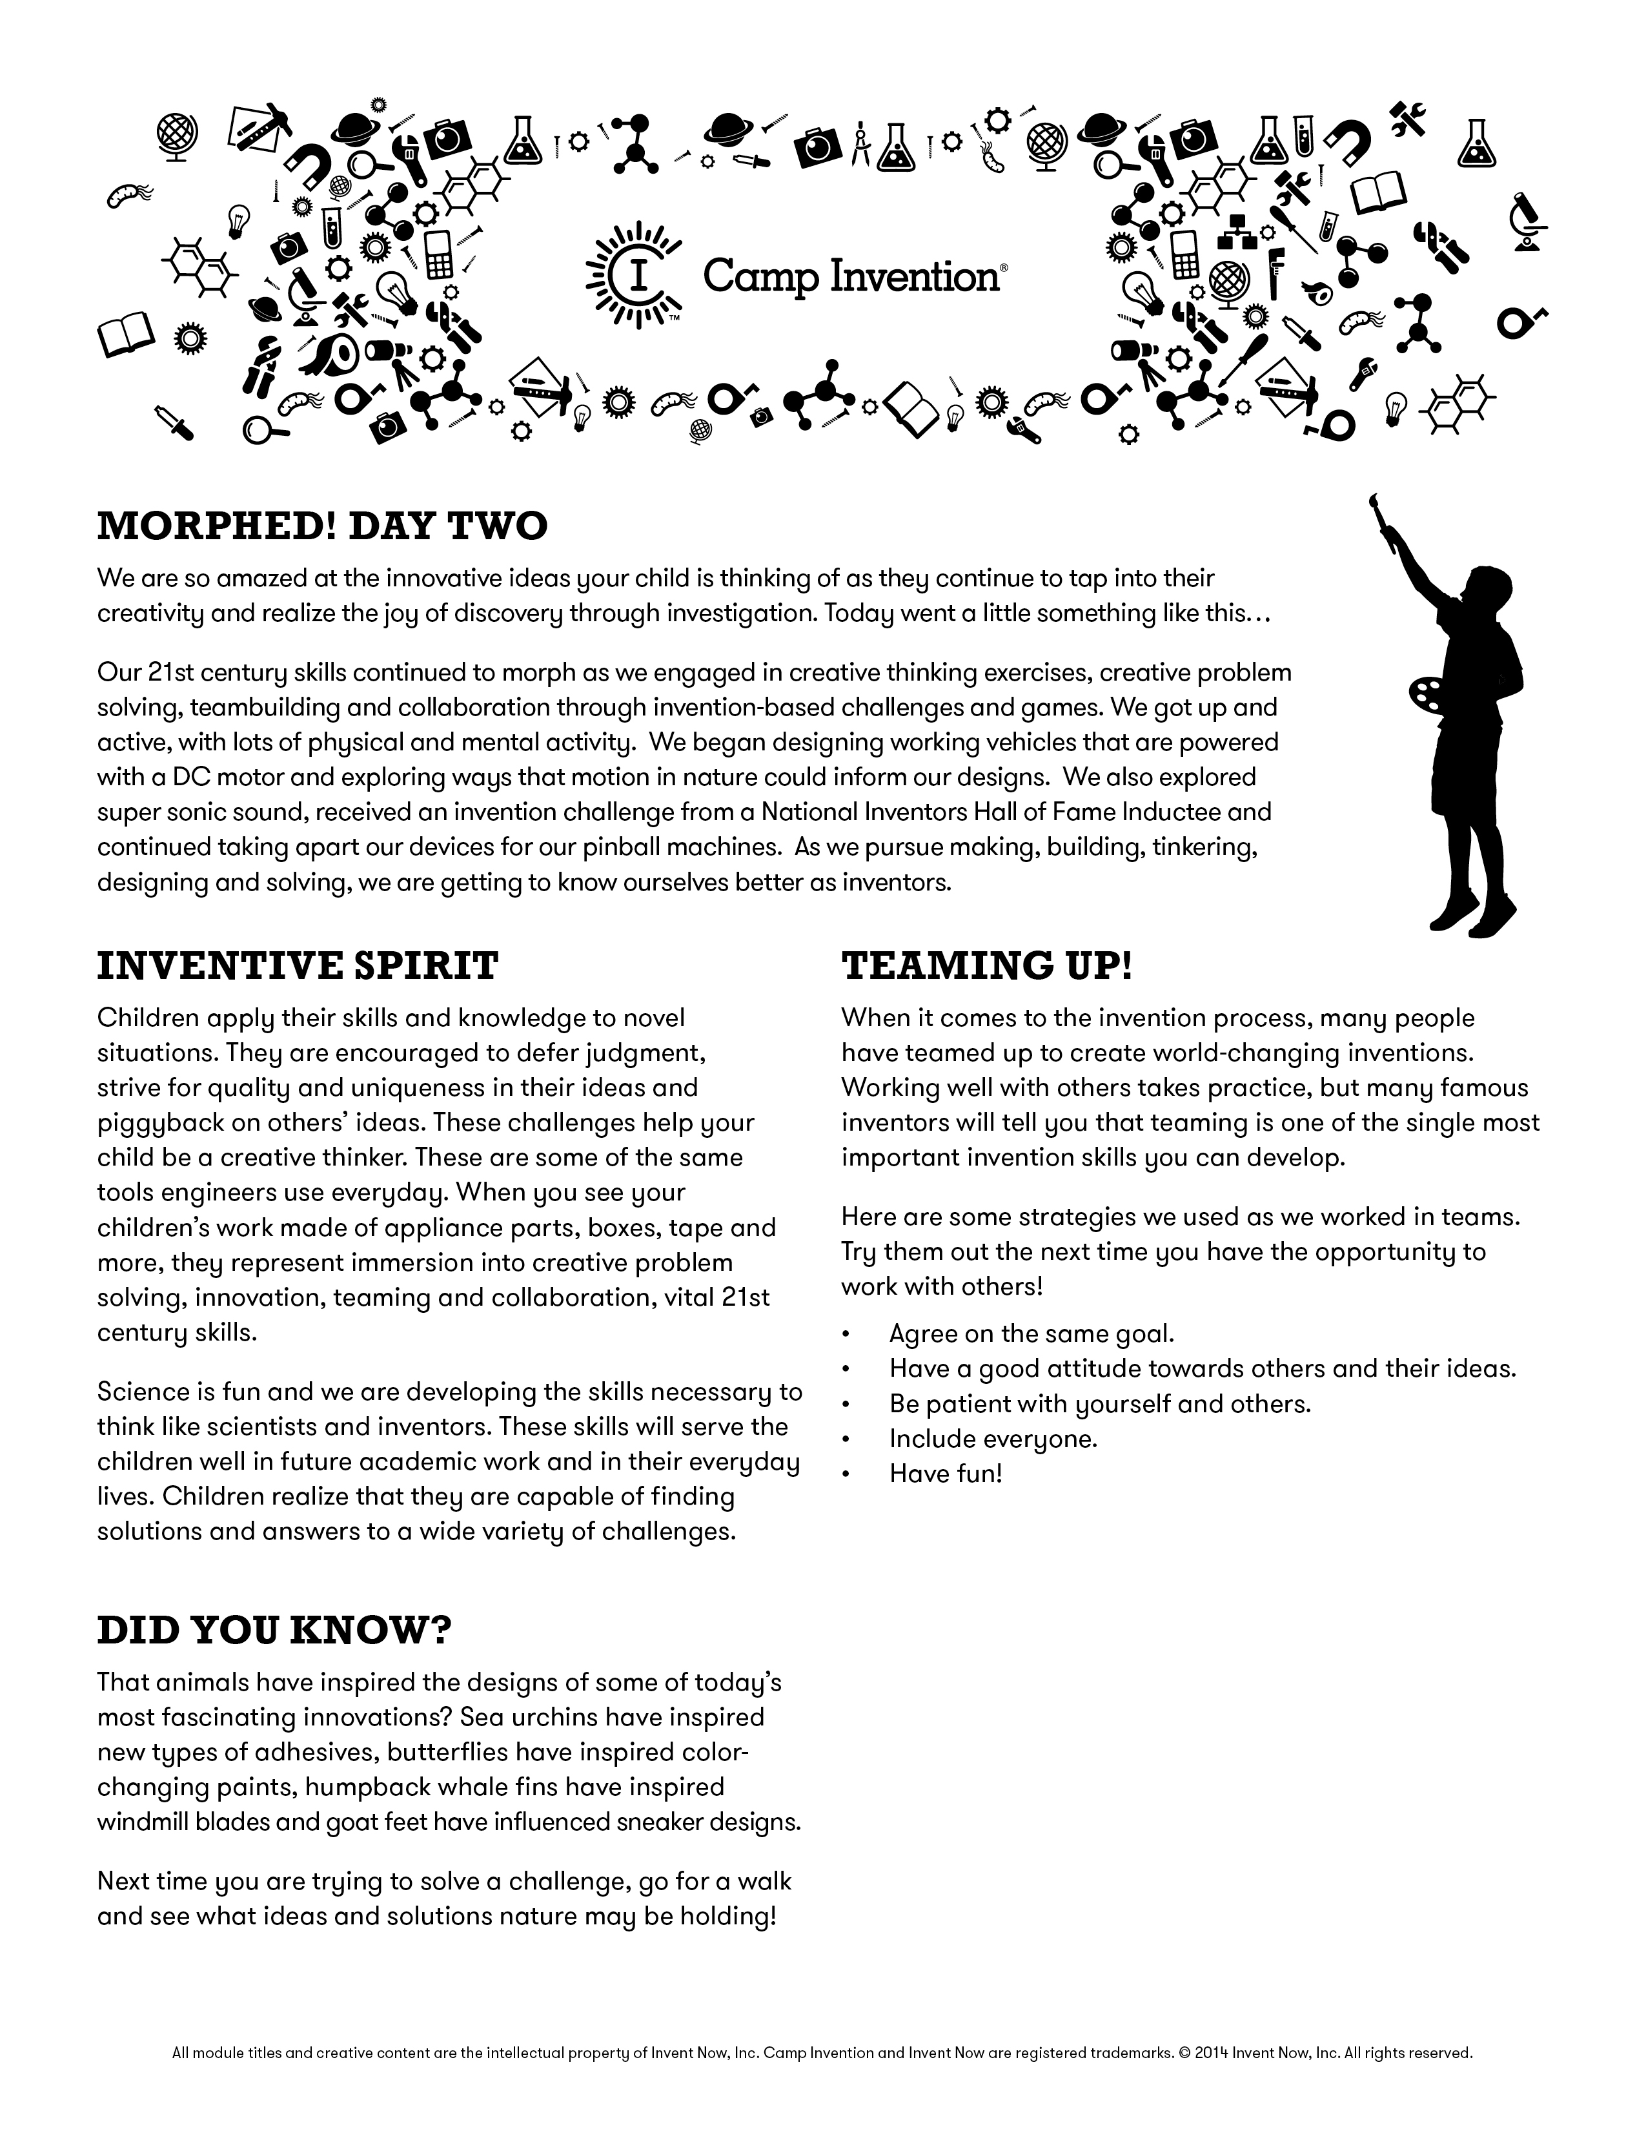
Tomorrow is Team Color Day… WEAR AS MUCH OF IT AS YOU CAN!
IMPORTANT INFO ON BACK!!!
CAMP TIMES:
Camp begins each morning at 9:00 am,
and concludes each day at 3:30 pm.
We ask that to facilitate drop off and pick up, you be mindful of the times.
As always…THANKS!

IMPORTANT INFO FOR PARENTSIn the event that we have rainy weather, our “pick up” process will change a bit. In order to keep the kids out of the weather, they will remain inside the gymnasium. All parents will come to the main office (same as “drop off”). They will sign out each of their campers and then proceed to the gymnasium to meet them and take them home! Thank you so much in advance for your cooperation!

Reminder
The Inventors Showcase program is scheduled to take place this Friday at 2:45pm in the gym. All family and friends are welcome and encouraged to come.

Emergency Phone Number
In the event that you need to contact us for any reason this week, please call (724) 327-5456, our secretary, Mrs. Lapaglia will page me to the office!
[Type a quote from the document or the summary of an interesting point. You can position the text box anywhere in the document. Use the Drawing Tools tab to change the formatting of the pull quote text box.]

SHARE WITH US
CAMP INVENTION F.A.Q.’s
- Can my child bring a water bottle? YES!
- Can I continue to bring recyclable items? YES!
- Do we still need to bring old appliances? Nope!
- Does Camp Invention need parent volunteers? Depending on the day/station we will include an
“ all call” in our newsletters asking for Parent Volunteers, if needed!
- What do I do if I need to pick my child up early? Please just come to the front office, find the Director (Mr. B) and he can locate your child!
- Will Camp Invention be back next year? YES!!!! Look for flyers next school year for early bird and “returning inventor” discounts!
Have you checked out our Facebook, Twitter and Google Plus pages? The links are on campinvention.org!

SPECIAL THANKS
The Camp Invention program is made possible through the assistance of a number of organizations, businesses and individuals that truly believe in the importance of inspiring our next generation of inventors.

Investors in Creativity
and Invention

United States Patent and Trademark Office,
an Agency of the Department of Commerce



