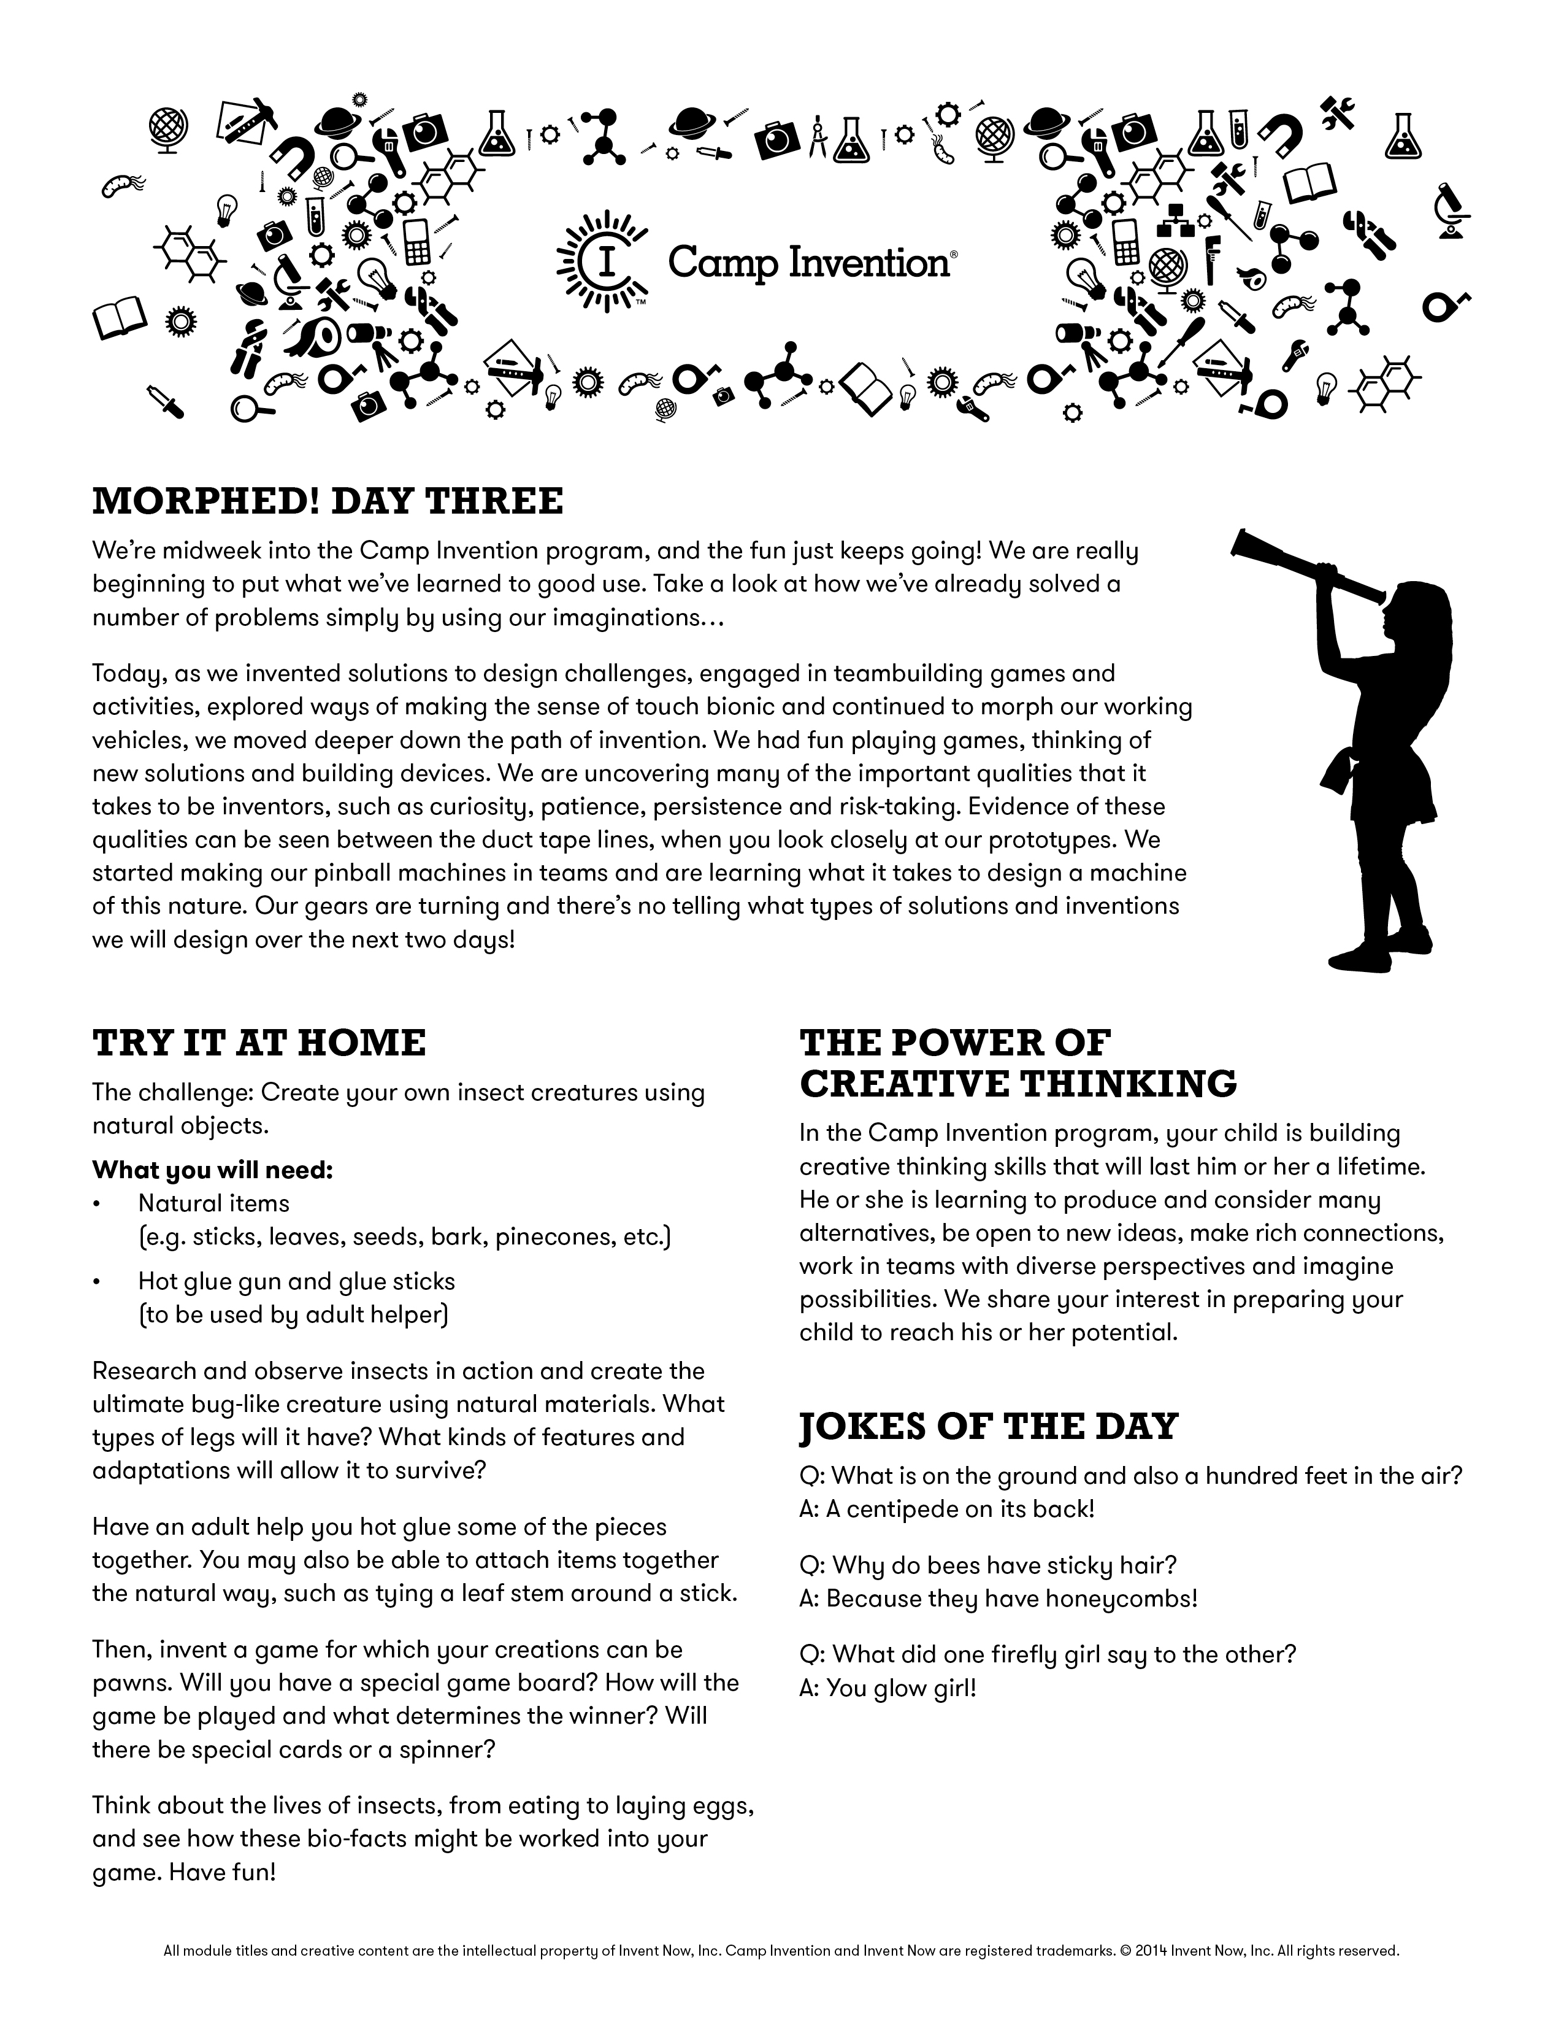
Tomorrow is “WE ARE - F.R.” DAY.
More information on back!

Wear your favorite Franklin Regional attire, or create combinations of Blue and Gold!!!

PARENTS
Your child’s safety is of the utmost importance to us. When dropping off and picking up your child, please be sure to sign them in and out each day. This is important for us to maintain accurate records regarding their whereabouts here at Camp Invention!

Reminder
The Inventors Showcase program is scheduled to take place this Friday at 2:45 in the Gym.
***All family and friends are welcome and encouraged to come.

Emergency Phone Number
In the event that you need to contact us for any reason this week, please call (724) 327-5456 extension 7002. Our Secretary will page me to the front office, or take and relay the message. Thanks!

C.I. Website
Our personalized Franklin Regional website is up and running. In addition to basic information about our camp, you can also find electronic versions of the Daily Newsletter and some “Inventors in Action” pictures. This site is updated daily, so check back often!
http://cidailyfrsd.yolasite.com/


SHARE WITH US
ADDITIONAL SUPPLIES NEEDED:
As our little scientists have been hard at work, our Station Directors have noticed that we are in need of some PAPER ROLLS
(wrapping paper, toilet paper, paper towel, etc.)
These seem to be one of the most sought after, and frequently used recyclables in the invention process!
Thank you so much in advance!
Visit www.youtube.com/campinvention to see Camp Invention videos!

SPECIAL THANKS
The Camp Invention program is made possible through the assistance, support, and commitment to Academic Enrichment Opportunities from the Franklin Regional Administrative Team!
Assistant Superintendent Mary Catherine Reljac and Heritage Principal Rob Buffone have been instrumental in making Camp Invention come to life!

Investors in Creativity
and Invention
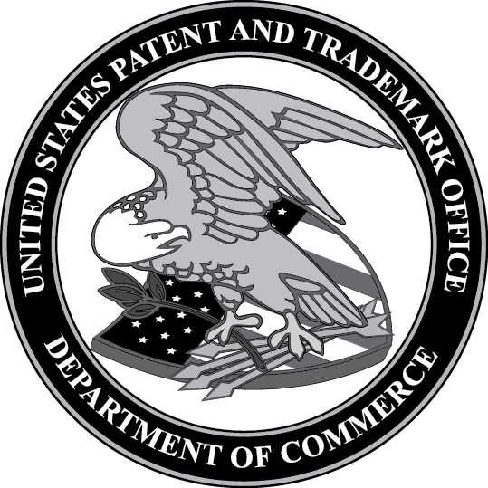
United States Patent and Trademark Office,
an Agency of the Department of Commerce
