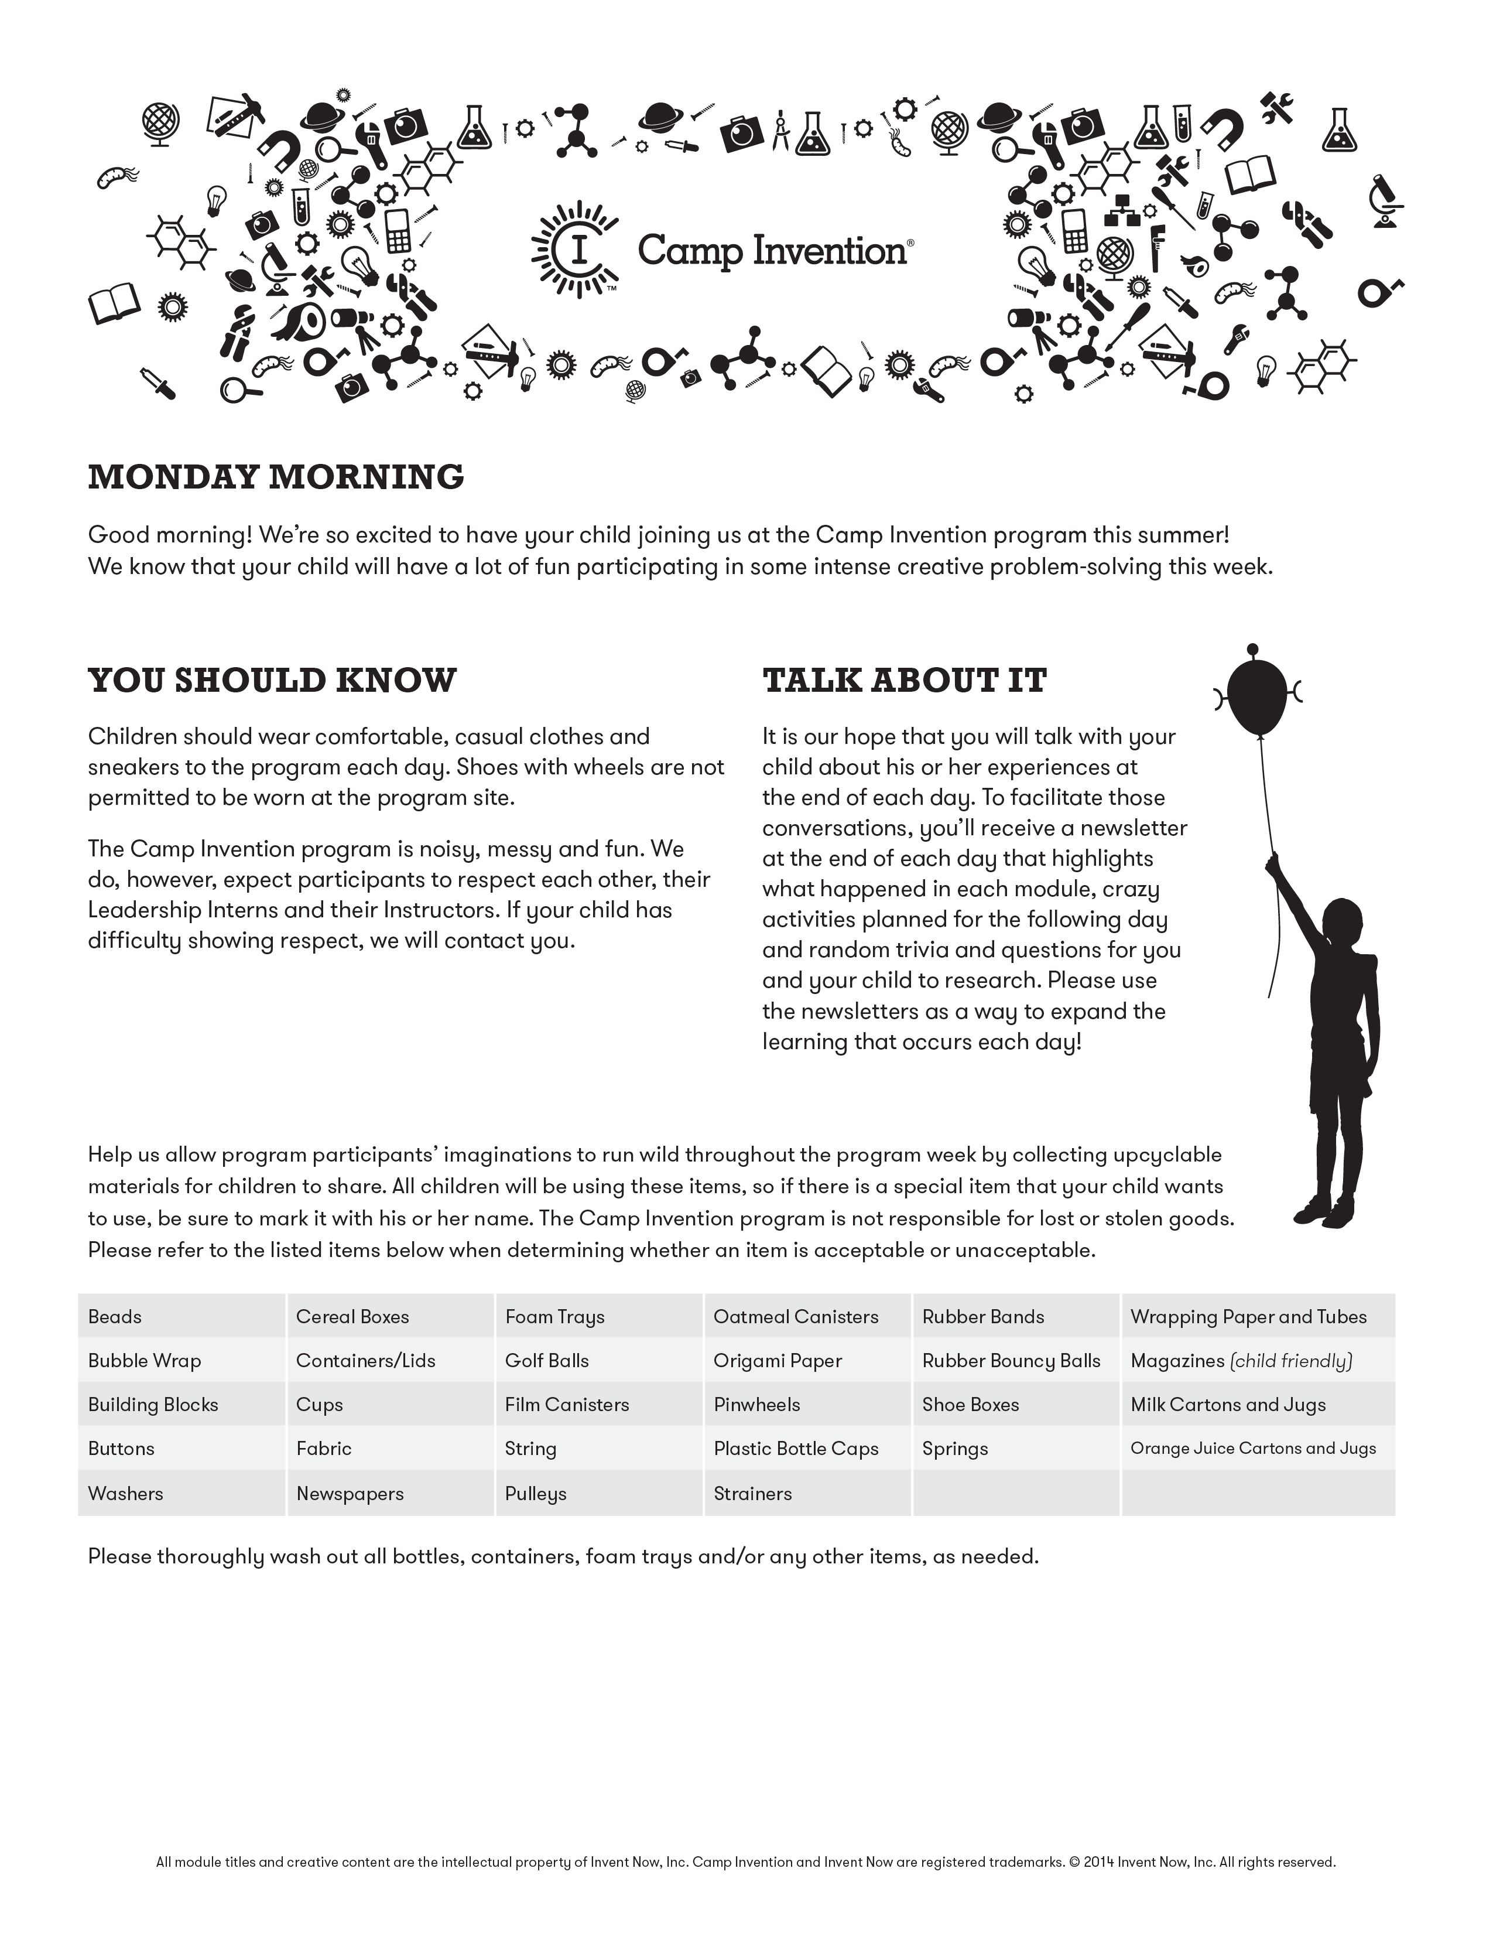



PARENTS
See reverse for important information regarding pick up and drop off,
as well as some other Camp Fun we will be having this week!
Your child’s safety is of the utmost importance to us. When dropping off your child you must accompany them to the main lobby and sign them in. When picking up your child, you must park in the side parking lot (by the playground equipment). You must meet the Camp instructor at the side door and sign them out each day. In the event that you need to contact us for any reason this week, please call (724) 327-5456, ask Mrs. Lapaglia to page Mr. Bielewicz.
Don’t forget to ask your child about his/her experience at the program each day.
Ask specific questions about each module based on the daily summaries provided, such as:
- What were some of the challenges you dealt with in your modules today?
- What do you think your best solution was?
- How did your groups ultimately come up with their solutions?
- What did you enjoy most about each module?
- What are you looking forward to tomorrow?
The hands-on, inquiry-based activities your child encounters at the Camp Invention program – paired with your expressed interest – will help your child get the most out of the experience. Note the boost in self-confidence and how his or her attitude toward working and problem solving in teams really develops.
Please remember to have your child bring a packed lunch, beverage and snack clearly marked with his or her name.

MARK YOUR CALENDARS
This Friday at 2:45pm, the children will be hosting the Inventors Showcase program. This is their chance to show off what they’ve been busy doing this week. All family and friends are welcome and encouraged to come.

Invent a snazzy new Camp Invention look every day!
This week at the Camp Invention program, we will be getting pretty creative. Each day, our outfits will match the explosions happening in our brains! Plan ahead and think of what kind of outfit you will wear each day. Don’t buy anything special! Upcycle and find items from your house to use for your outfit!
Tuesday is Crazy Hat Day
Wednesday is Team Color Day

(wear as much of it as you can!)
Thursday is We are FR Day
(or blue and gold colors)
Friday is Camp T-shirt Day

SHARE WITH US
Don’t forget to check-in on
Facebook each day this week!

SPECIAL THANKS
The Camp Invention program is made possible through the assistance of a number of organizations, businesses and individuals that truly believe in the importance of inspiring our next generation of inventors.


Investors in Creativity
and Invention

United States Patent and Trademark Office,
an Agency of the Department of Commerce



